Western Sydney International Is Reshaping Sydney’s Industrial Landscape
The development of Western Sydney International Airport (WSI) and the surrounding Aerotropolis is creating a new industrial and logistics market in Sydney’s west. Arealytics independently verified data shows how quickly commencing lease rates are increasing when compared with Alexandria, the established industrial market near Sydney Airport. Between 2022 and 2026, median commencing lease rates across Kemps Creek and Badgerys Creek increased 94.2%, from $121/m² to $235/m², compared with a 68.6% increase in Alexandria, from $255/m² to $430/m².
Alexandria continues to command a significant rental premium, supported by its proximity to Sydney Kingsford Smith Airport (SYD), the CBD and Port Botany, as well as increasingly constrained industrial land supply. However, the stronger rental growth recorded across Kemps Creek and Badgerys Creek shows how quickly the value equation is changing around WSI as infrastructure, development and occupier activity build.
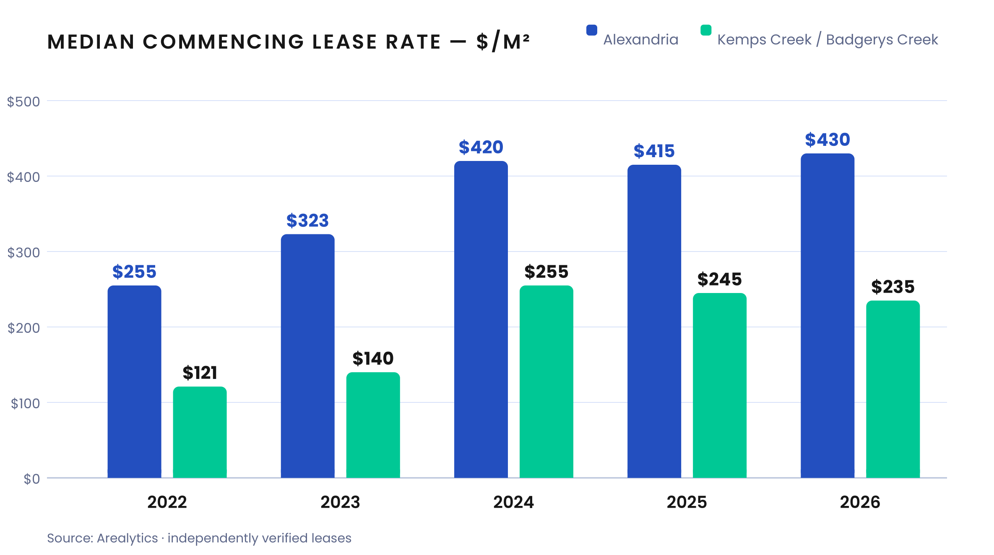
Growth is Extending Well Beyond the Airport Boundary
Importantly, growth is extending well beyond the airport boundary. WSI sits at the centre of a network of major employment and industrial precincts, including the Mamre Road Precinct at Kemps Creek (more than 850 hectares), Northern Gateway at Luddenham and Badgerys Creek (approximately 1400 hectares), Bradfield City Centre and the broader Aerotropolis precinct. These areas are supporting logistics, distribution, advanced manufacturing, research and other airport-linked industries, creating a broader industrial cluster around WSI.
The scale of this emerging market is already evident in Arealytics data. In 2026 to date, the median industrial space leased across Kemps Creek and Badgerys Creek was 9,018 m², compared with just 317 m² in Alexandria. The difference extends to the existing building stock, with 22 industrial buildings above 15,000 m² across Kemps Creek and Badgerys Creek, twice the number recorded in Alexandria. Combined with substantial new industrial construction, these larger-format facilities and landholdings provide the capacity for modern warehouses, distribution centres and logistics operations that are increasingly difficult to accommodate in Sydney’s established inner industrial markets.

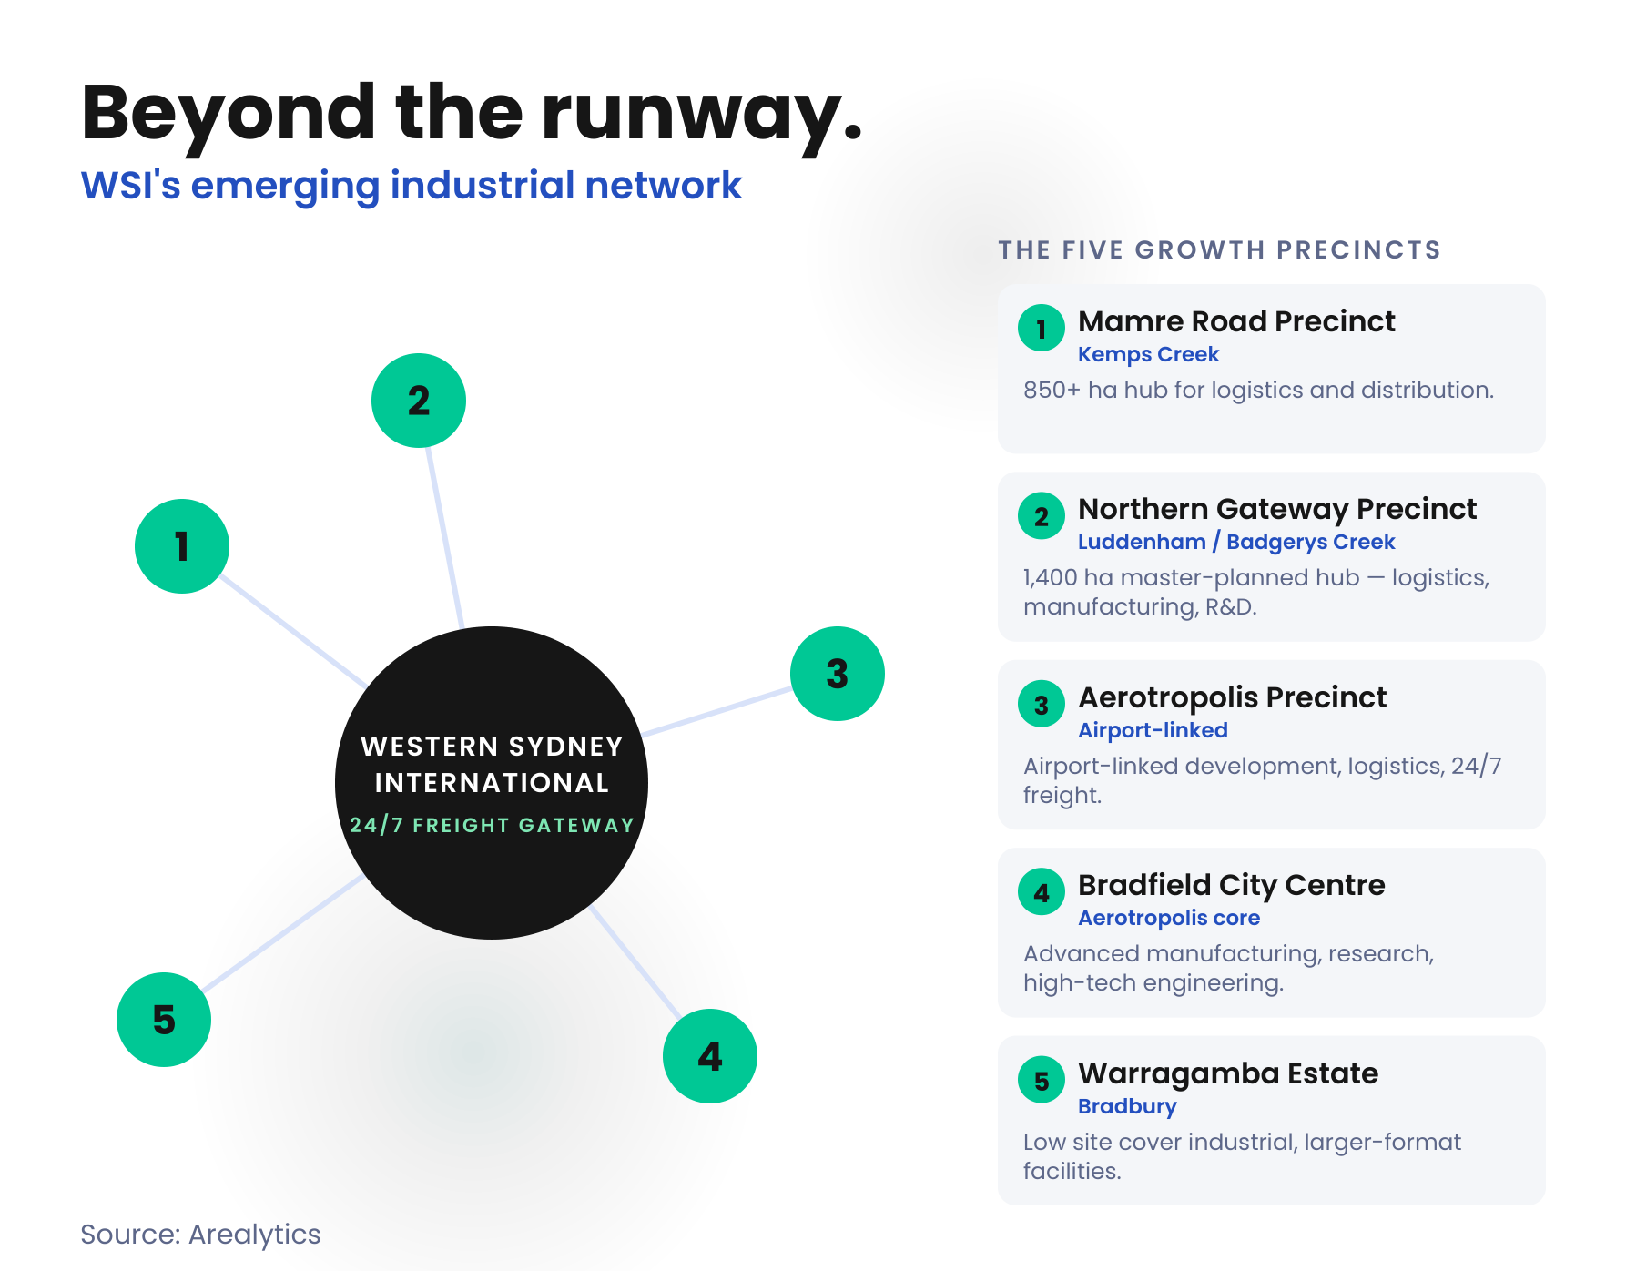
What Shapes the Next Stage
The next stage of growth will be shaped by the interaction between this new supply and demand generated by WSI and its surrounding infrastructure. The airport’s 24-hour operations, together with the M12 Motorway, upgrades to The Northern Road and the Sydney Metro Western Sydney Airport line, are strengthening connections between WSI, surrounding growth corridors and the wider Sydney market.
Major occupiers are already positioning themselves within this network, including O’Brien’s commitment to a 17,000 m² purpose-built facility in the WSI Business Precinct. Alexandria provides a useful benchmark for the rental premium associated with a mature and highly constrained airport industrial market, while Kemps Creek and Badgerys Creek are developing a different proposition built around scale, new industrial supply and 24-hour freight connectivity. With median commencing rents around WSI nearly doubling since 2022, the question is no longer whether a second major industrial market is forming. It is how fast the gap closes between the two.
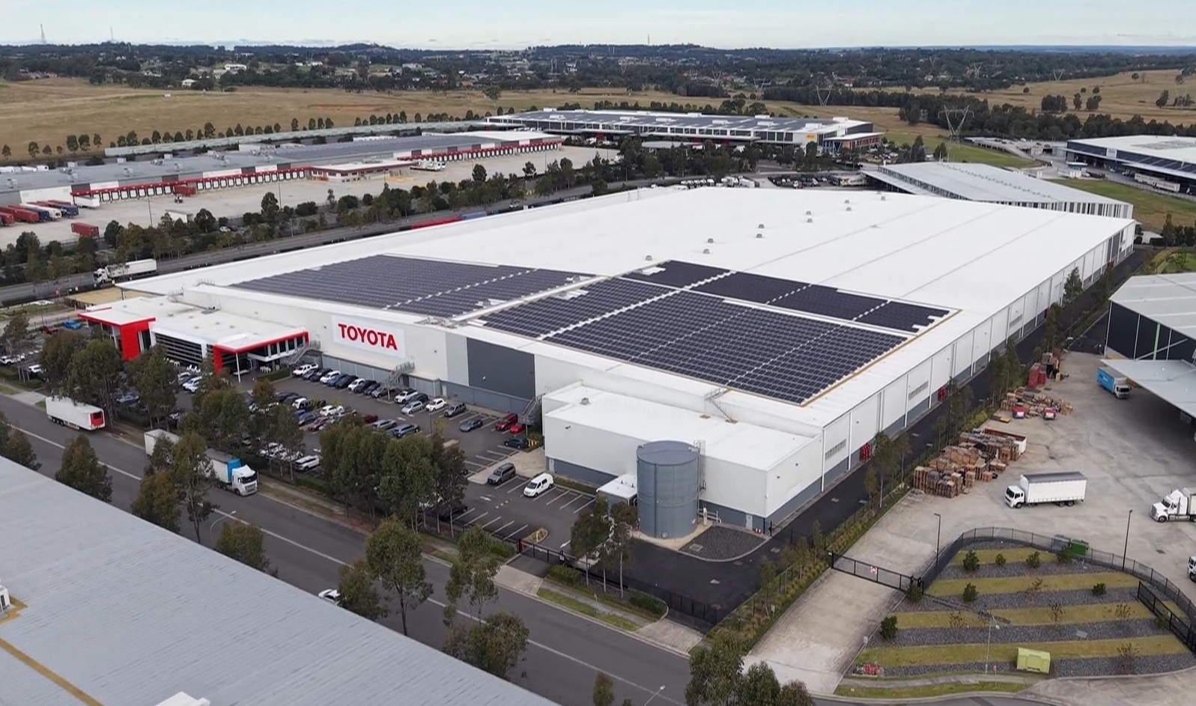
Drone imagery of the growing industrial sector of Kemps Creek.
Source: Arealytics
Analysis is based on transactions and property information captured and independently verified by Arealytics across Kemps Creek, Badgerys Creek and Alexandria, 2022 to 2026, and may not represent all market activity. 2026 figures are year to date. Lease rates are median commencing [net/gross] face rents. Figures reflect the position at the time of publication.

