When Power Becomes Property Value: How Data Centres Are Repricing Western Sydney Industrial Land
For years, industrial property value has been defined by traditional fundamentals: land, labor, transport, and customer access. In Western Sydney, a new variable is shifting the equation: power. As data centre land demand intensifies, organisations are increasingly prioritising sites that can support massive electricity requirements. This trend is driving a measurable pricing premium in Greater Sydney submarkets with high-capacity power infrastructure. Arealytics’ analysis of independently verified industrial land sales and asset performance from 2021 to 2026 reveals that this shift extends far beyond the data centres themselves, fundamentally altering property economics across Greater Sydney.
Start with Land
We started with the land. To keep the analysis focused on large-scale development opportunities, only land sales of 10 hectares or more were included. Kemps Creek stood out immediately. Across the Kemps Creek land sales analysed, the median land rate was $326.93/m², compared with $216.27/m² across Greater Sydney, a 51.2% premium.
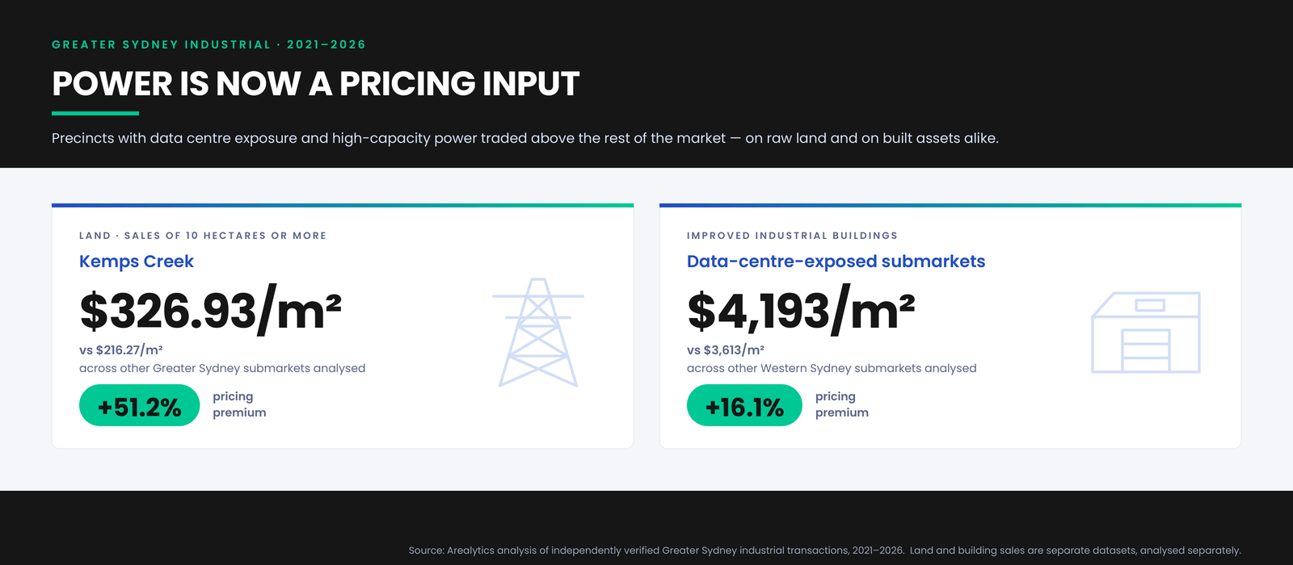

The land pricing trend is just as telling. Ten of the 11 highest land rates in the dataset were recorded in Kemps Creek. Over the period analysed, the median Kemps Creek land rate increased from $251.82/m² to $367.68/m², a rise of 46.0%.
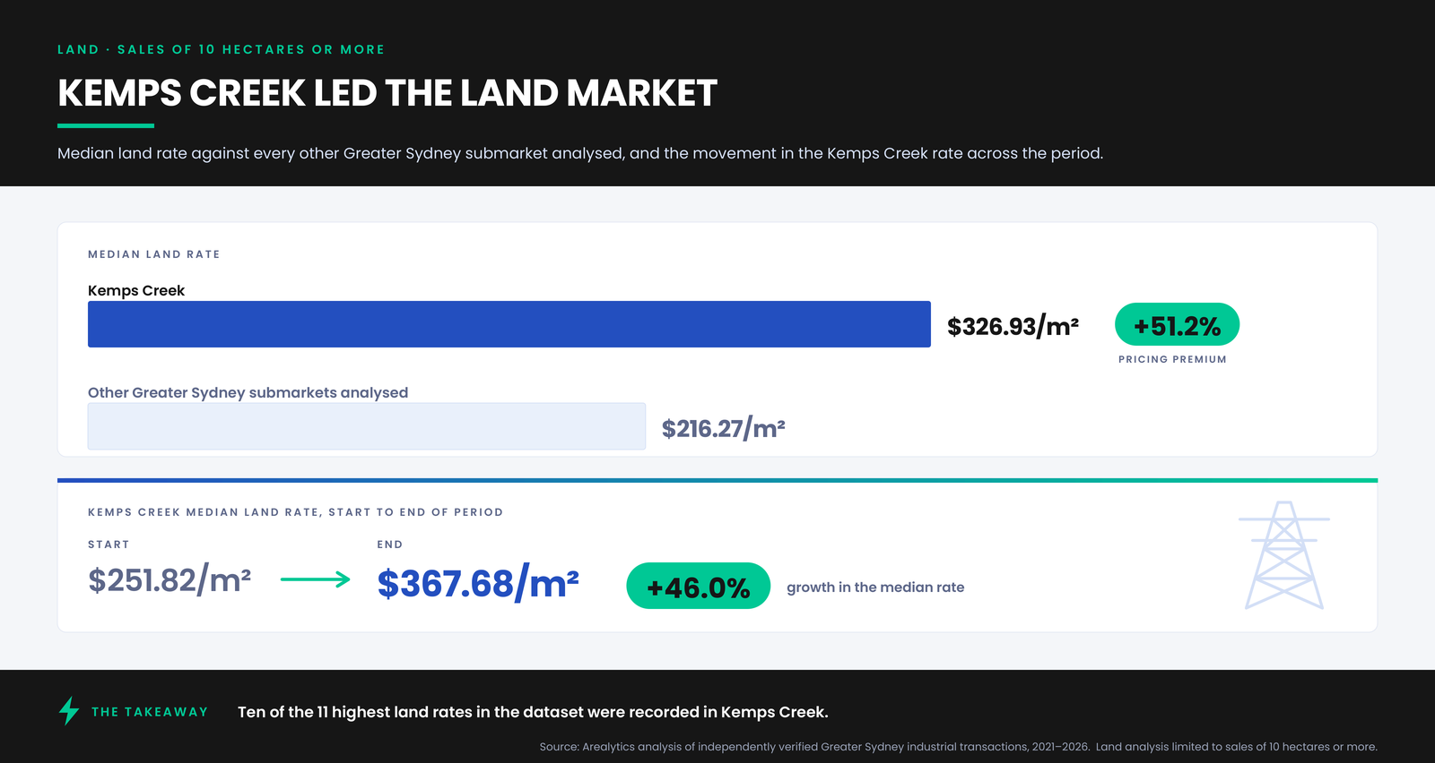
These are not all data centre acquisitions. Industrial and logistics users are also buying and developing large sites in the same precincts. A property does not have to become a data centre to feel the effects of data centre demand.
That shift is already taking shape in Kemps Creek. Microsoft has developed a major data centre campus in the Mamre Road Precinct, with its first building completed in 2026. Projects of this scale compete for the same large, well-located industrial land sought by logistics developers, manufacturers and other occupiers, while placing an even greater emphasis on access to reliable, high-capacity electricity.
The Same Pattern in Built Assets
The same pattern appears when analysing industrial buildings transactions. Across the 2021 to 2026 period, freehold industrial building sales in data-centre-exposed Western Sydney markets, including Eastern Creek, Huntingwood, Erskine Park and Seven Hills, recorded a median sale rate of $4,193/m². That compares with $3,613/m² across the other Western Sydney industrial markets analysed, a 16.1% premium.

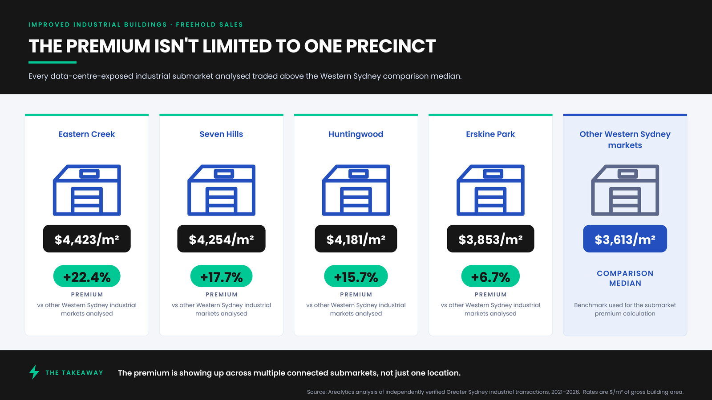

Eastern Creek is already home to a major concentration of digital infrastructure, including CDC’s campus, which has grown to more than 200 MW of capacity across multiple facilities. At the same time, warehouses and logistics facilities continue to experience strong demand, driving new development and increasing occupancy around the new Western Sydney International Airport.
Land sales and improved building sales are separate datasets and were analysed separately. Both point the same way: precincts with significant data centre exposure and access to major power infrastructure command a pricing premium.
What this means for Industrial Value
For industrial property, roads, labour, logistics networks and access to customers still matter. But in parts of Western Sydney, the location equation is changing.
Power is no longer just an infrastructure consideration. In Western Sydney’s fastest-growing industrial precincts, it’s a pricing input
Methodology: Analysis is based on land and building transactions captured and independently verified by Arealytics across Greater Sydney, 2021 to 2026, and may not represent all market activity. Land analysis is limited to sales of 10 hectares or more. Building analysis covers freehold industrial sales; rates are $/m² of gross building area / lettable. 2026 figures are year to date. Figures reflect the position at the time of publication.
Data for first image:
Land | 10+ Hectare Sales
Kemps Creek
- Median sale rate: $326.93/m²
- Other Greater Sydney submarkets analysed: $216.27/m²
- Pricing premium: +51.2%

Data for second image:
Comparison benchmark
- Other Western Sydney markets median sale rate: $3,613/m²
Eastern Creek
- Median sale rate: $4,423/m²
- Premium to comparison benchmark: +22.4%
- Calculation: ($4,423 ÷ $3,613 − 1) × 100 = 22.4%
Seven Hills
- Median sale rate: $4,254/m²
- Premium to comparison benchmark: +17.7%
- Calculation: ($4,254 ÷ $3,613 − 1) × 100 = 17.7%
Huntingwood
- Median sale rate: $4,181/m²
- Premium to comparison benchmark: +15.7%
- Calculation: ($4,181 ÷ $3,613 − 1) × 100 = 15.7%
Erskine Park
- Median sale rate: $3,853/m²
- Premium to comparison benchmark: +6.7%
- Calculation: ($3,853 ÷ $3,613 − 1) × 100 = 6.7%

